**TECHNICAL**

1. **Fields of Web Applications:**

Web applications are useful in many areas of business and other needs. Given below is the list of categories where in the Web technologies are useful.

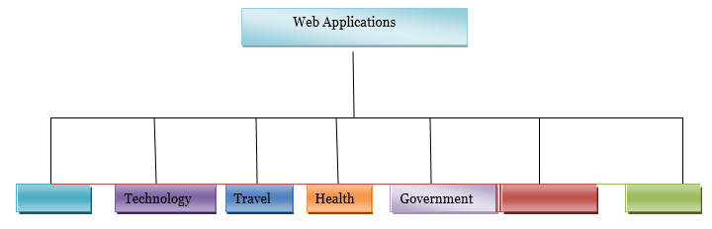

There are many Web technologies available in the market as of now. Every Web technology can deliver the same functionalities required for an application in its own style. Because this project is a community web format exchange between skill everyone should have a new development trend.

1. **Competitive Web Technologies:**

Some of the prominent technologies that are mostly used in developing and implementing Web applications are ASP.NET, PHP, ColdFusion, Perl, Python, J2EE, Ruby on Rails and many more.Below table for the usage of different Web technologies in the present market.

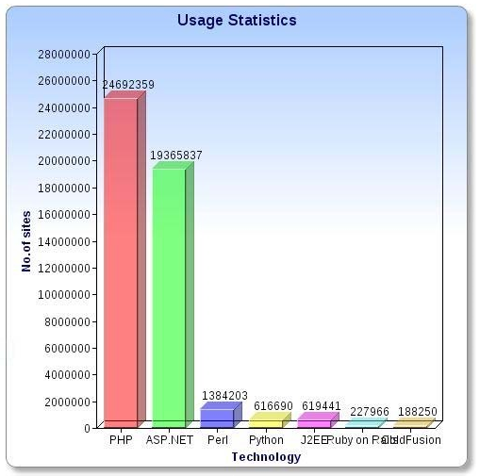

As statistics on current users. We see language PHP is the most potential as web programming.

1. **Future: Use framework**

|  |  |  |  |  |  |  |  |
| --- | --- | --- | --- | --- | --- | --- | --- |
| Future | Registration | Log in | View | Manage | Upload photo | Add Comment | Count |
| ASP.net (C#) | X | X |  | X | X | X | 5 |
| PHP | X | X |  | X |  | X | 4 |

We can see, there are not many PHP frameworks support future with ASP.net (C #). The majority of the future when programming in PHP, we had to code. But ASP.net (C #) can support more vulnerable to conflict, but as the Future framework can not operate like that.

1. **PHP vs ASP.net (C#):**

|  |  |
| --- | --- |
| PHP | ASP.net (C#) |
| * Laravel, Bootstrap… * WAMP * Apache server * My SQL * Dreamweaver * PHP content pages | * .net Framework * SQL server * ASP.net development server * Visual Web Developer 2010 express * Master Pages * ASP.net content pages |

|  |  |  |
| --- | --- | --- |
| **Features** | **ASP.NET** | **PHP** |
| Cost | Need to buy | Free |
| Speed | Yes | No |
| Language Support | Many | No |
| Editors | Visual Studio | Zend, Eclipse, Code Lobster, Adobe Dreamweaver, Net Beans, Context, etc., |
| Database Compatibility | MS‐SQL, MySQL | MS‐SQL, MySQL |
| Coding | 325 lines of code for main functionalities | 386 lines of code for main functionalities |
| Platform Connectivity | Windows | Many (Windows, LINUX, UNX) |
| Support | Updates are available from Microsoft | More support from PHP forum/blog |
| Tools | Available inside the Visual Studio | Have to gather from the third party |
| Space | 23MB | 3MB |
| Designing code | Automatic | Manual |
| Data Controls | Yes | No |
| Validation Controls | Yes | No |

Convention: orange box is 1 point, the white box is 0 points and the blue box is not included.

|  |  |  |
| --- | --- | --- |
| **Features** | **ASP.NET** | **PHP** |
| **Count** | 3 | 9 |

**Through PHP and ASP.net table comparing (C #), we can see:**

* PHP is completely free, and ASP.net (C #) need to pay for some framework you use.
* Speed when using ASP.net (C #) slower because of the need to use PHP framework to run a lot. Besides, ASP.net (C #) to support multiple languages.
* PHP can use many tools to project implementation. And ASP.net (C #) can only use a single tool is Visual Studio…
* PHP can see agility and convenience to the project implementation than ASP.net (C #).

1. **Quality:**

|  |  |  |
| --- | --- | --- |
| **Features** | **ASP.NET** | **PHP** |
| Userbility | Yes | Yes |
| Maintainability | No | Yes |
| Security | Yes | Yes |

PHP harder to maintain because the framework was tied compelled to mold created by Visual Studio, so it may be affecting the original product. As for PHP, the code can be edited or changed without affecting the entire product when maintenance.

1. **Summary :**

* PHP has many advantages better ASP.net (C #) and quite suitable for the project. So the group decided to project implementation PHP Vina SWAP.